UNITED STATES
SECURITIES AND EXCHANGE COMMISSION
Washington, D.C. 20549
SCHEDULE 14A
PROXY STATEMENT PURSUANT TO SECTION 14(a) OF THE
SECURITIES EXCHANGE ACT OF 1934
Filed by the Registrant ☒
Filed by a party other than the Registrant ☐
Check the appropriate box:
☐ Preliminary Proxy Statement
☐ Confidential, for Use of the Commission Only (as permitted by Rule 14a-6(e)(2))
☐ Definitive Proxy Statement
☒ Definitive Additional Materials
☐ Soliciting Material Pursuant to §240.14a-12

CRICUT, INC.
(Name of Registrant as Specified In Its Charter)

(Name of Person(s) Filing Proxy Statement, if other than the Registrant)

Payment of Filing Fee (Check all boxes that apply):
☒ No fee required.
☐ Fee paid previously with preliminary materials.
☐ Fee computed on table in exhibit required by Item 25(b) per Exchange Act Rules 14a-6(i)(1) and 0-11.

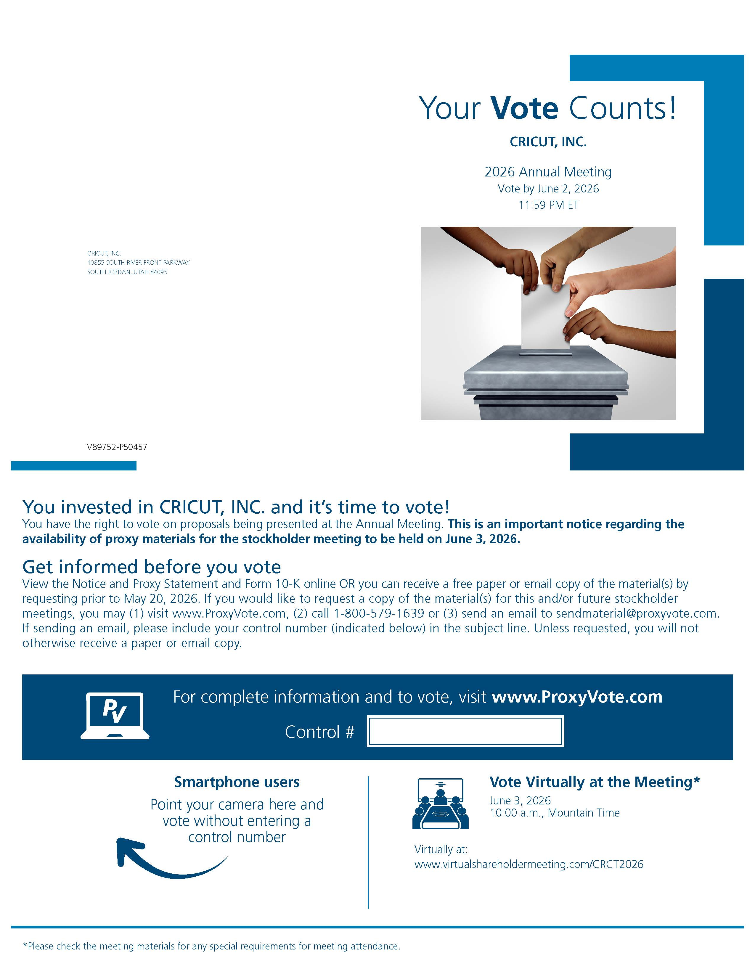
-2-

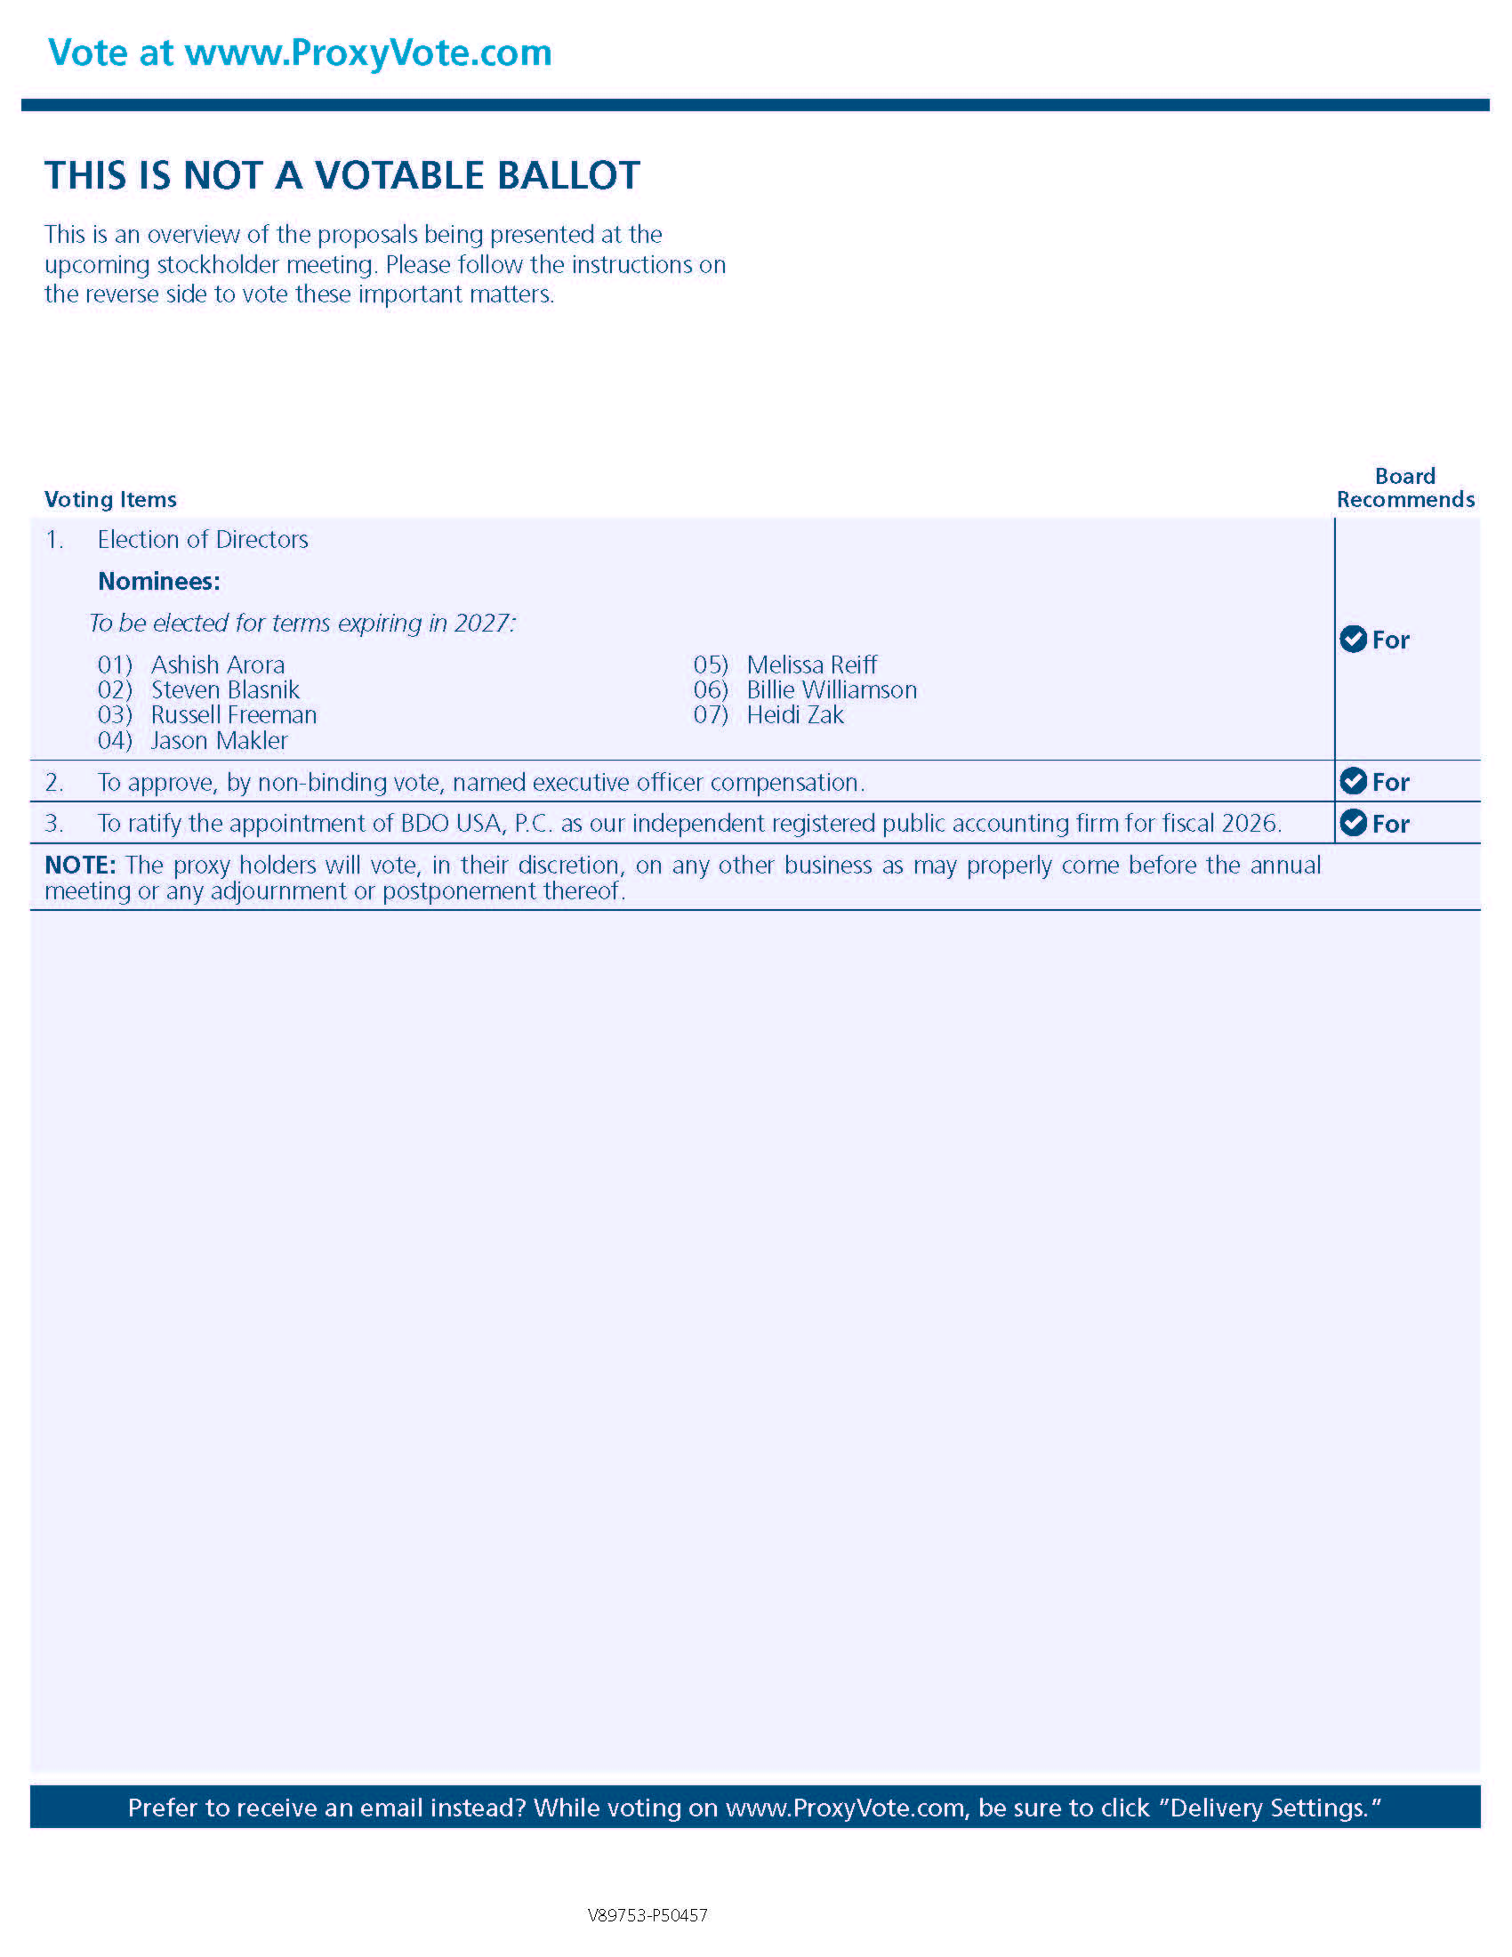
-3-

